**Week 4 Module 5.3 Assignment**

Juan Macias Vasquez

Bellevue University

CSD310-H323 Database Development and Use (2255-DD)

**Adam Bailey**

June 22th, 2025

Module 5.3 Assignment Film ERD

Assignment: ERD Studio, Genre, Film

ERD picture

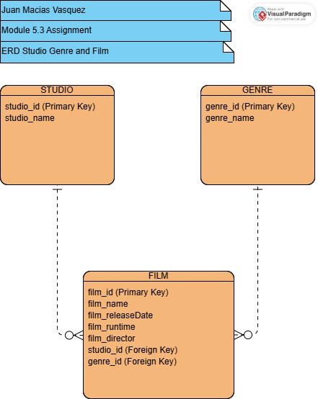

ERD made in Visual Paradigm

<https://online.visual-paradigm.com/>